Total Dataset : Fragile(301 images), handle(103 images), up(171 images), wet(113 images)

Train_test dataset : 80% : 20%  
 Fragile(232 images), handle(83 images), up(149 images), wet(86 images)

(test) Fragile(69 images), handle(20 images), up(22 images), wet(69 images)

**Train set으로 훈련 후 train set으로 평가 (threshold=0.5(default))**

오차 행렬

[[318 0]

[ 0 232]]

정확도: 1.0000, 정밀도: 1.0000, 재현율: 1.0000, F1:1.0000

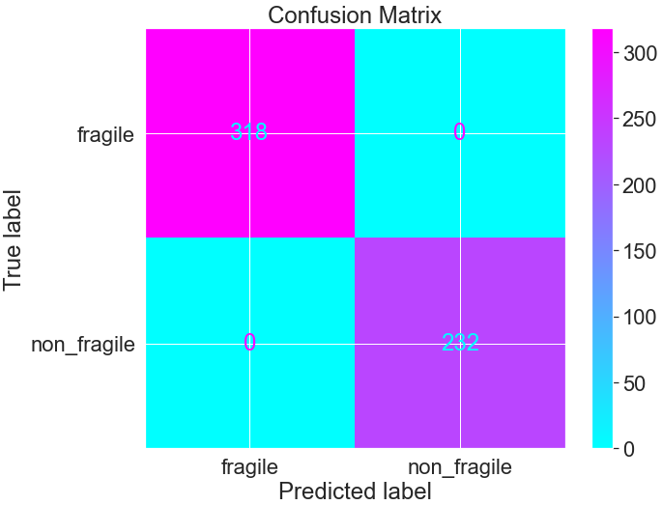Train_set으로 평가했을 때 문제 없음

<예측확률>

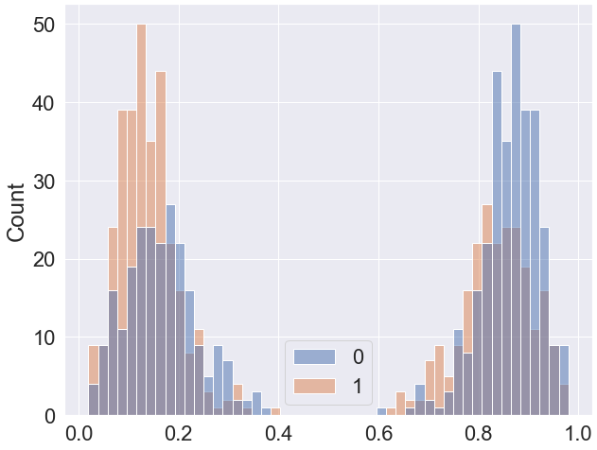 🡪 임계치 조정 전 예측확률 시각화

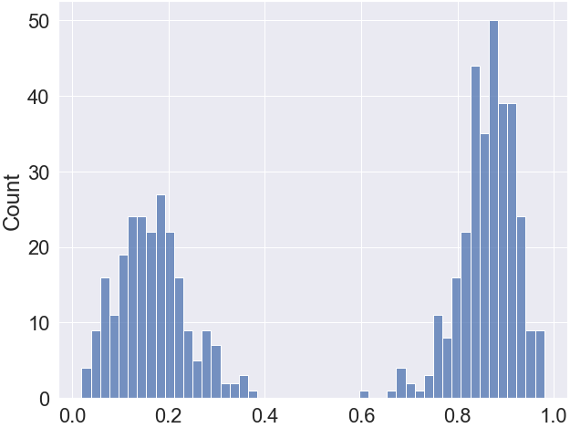 🡪 fragile==True일 때 예측확률

**Test set으로 성능평가**

오차 행렬

[[61 8]

[30 39]]

정확도: 0.7246, 정밀도: 0.8298, 재현율: 0.5652, F1:0.6724

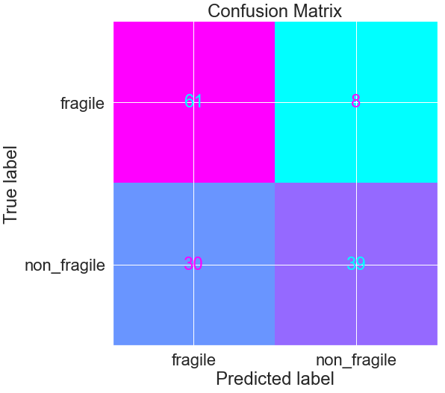 threshold = 0.5

**임계값 변화**

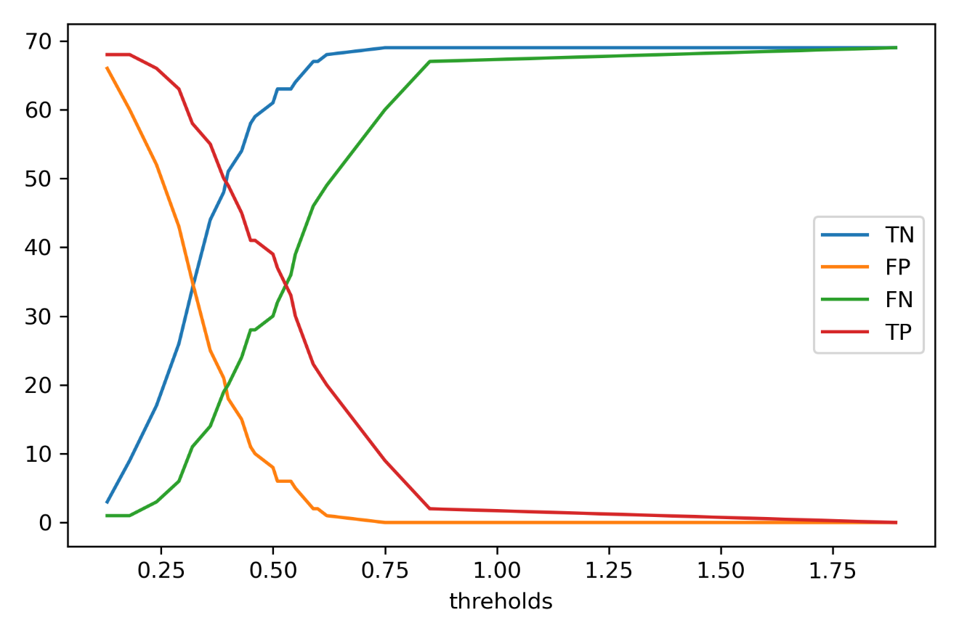

<fig. 임계값 변화에 따른 TN, FP, FN, TP 변화>

|  |  |  |  |  |  |  |  |  |  |  |
| --- | --- | --- | --- | --- | --- | --- | --- | --- | --- | --- |
|  | thresholds | TN | FP | FN | TP | Accuracy | Precison | Recall | F1 | AUC |
| 0 | 1.89 | 69 | 0 | 69 | 0 | 0.500 | 0.000 | 0.000 | 0.000 | 0.500 |
| 1 | 0.85 | 69 | 0 | 67 | 2 | 0.5145 | 1.000 | 0.029 | 0.0563 | 0.5145 |
| 2 | 0.75 | 69 | 0 | 60 | 9 | 0.5652 | 1.000 | 0.1304 | 0.2308 | 0.5652 |
| 3 | 0.62 | 68 | 1 | 49 | 20 | 0.637 | 0.9524 | 0.289 | 0.444 | 0.637 |
| 4 | 0.59 | 67 | 2 | 46 | 23 | 0.652 | 0.920 | 0.333 | 0.4894 | 0.652 |
| 5 | 0.55 | 64 | 5 | 39 | 30 | 0.681 | 0.857 | 0.434 | 0.576 | 0.681 |
| 6 | 0.54 | 63 | 6 | 36 | 33 | 0.695 | 0.846 | 0.478 | 0.611 | 0.695 |
| 7 | 0.51 | 63 | 6 | 32 | 37 | 0.724 | 0.860 | 0.536 | 0.607 | 0.724 |
| 8 | 0.5 | 61 | 8 | 30 | 39 | 0.724 | 0.829 | 0.565 | 0.674 | 0.724 |
| 9 | 0.46 | 59 | 10 | 28 | 41 | 0.724 | 0.803 | 0.594 | 0.688 | 0.724 |
| 10 | 0.45 | 58 | 11 | 28 | 41 | 0.717 | 0.788 | 0.594 | 0.677 | 0.717 |
| 11 | 0.43 | 54 | 15 | 24 | 45 | 0.717 | 0.750 | 0.652 | 0.697 | 0.717 |
| 12 | 0.4 | 51 | 18 | 20 | 49 | 0.724 | 0.731 | 0.710 | 0.720 | 0.724 |
| 13 | 0.39 | 48 | 21 | 19 | 50 | 0.710 | 0.704 | 0.724 | 0.714 | 0.710 |
| 14 | 0.36 | 44 | 25 | 14 | 55 | 0.717 | 0.687 | 0.797 | 0.738 | 0.717 |
| 15 | 0.32 | 34 | 35 | 11 | 58 | 0.666 | 0.623 | 0.840 | 0.716 | 0.666 |
| 16 | 0.29 | 26 | 43 | 6 | 63 | 0.644 | 0.594 | 0.913 | 0.720 | 0.644 |
| 17 | 0.24 | 17 | 52 | 3 | 66 | 0.601 | 0.559 | 0.956 | 0.705 | 0.601 |
| 18 | 0.18 | 9 | 60 | 1 | 68 | 0.558 | 0.531 | 0.985 | 0.690 | 0.558 |
| 19 | 0.13 | 3 | 66 | 1 | 68 | 0.514 | 0.507 | 0.985 | 0.670 | 0.514 |

<Table 임계값 변화에 따른 TN, FP, FN, TP 변화>

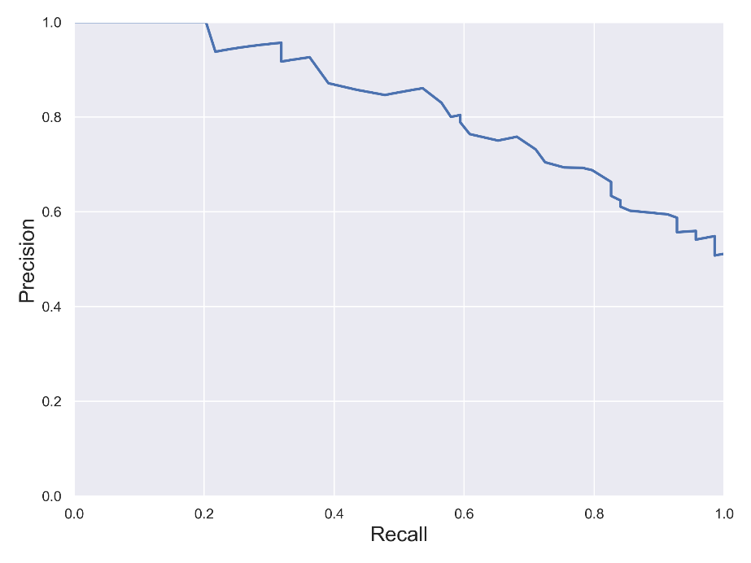

<fig2. 임계값 변화에 따른 precision/recall변화>

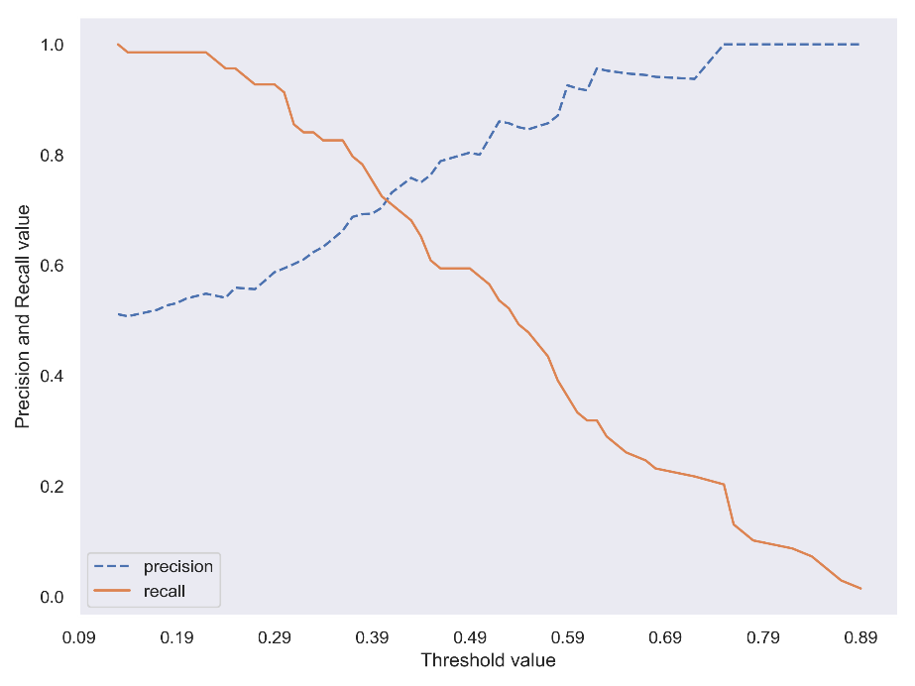

<fig3. 임계값 변화에 따른 precision/recall변화>